WIKI SEARCH

https://2020.igem.org/Team:SCU-WestChina/model - one with nice PD-PK model
Other wikis whose models may be useful
https://2013.igem.org/Team:NJU_China/Modeling
https://2012.igem.org/Team:Slovenia/ModelingPK https://2012.igem.org/Team:Slovenia/Modeling
https://2020.igem.org/Team:NJU-China/Model
The following can be done.
Finally, we developed a model to predict affordability of NSCLC treatment based on disposable income and Engel's coefficient of residents in China, the United States and the United Kingdom.
1)Drug elimination kinetics
dc/dt=−kc^n
c = drug concentration
k = elimination rate constant.
When n = 1, primary kinetics, the drug is eliminated at a constant ratio, the rate of elimination is proportional to its concentration, and most drugs follow primary elimination kinetics. When n = 0, it is a zero - level kinetic, with constant drug elimination and constant drug elimination rate, and when the drug concentration is high, it is a constant elimination rate.
https://2022.igem.wiki/nju-china/model/epidemiology-analysis/

Epidemiology analysis of androgenetic alopecia (we can do something like this)

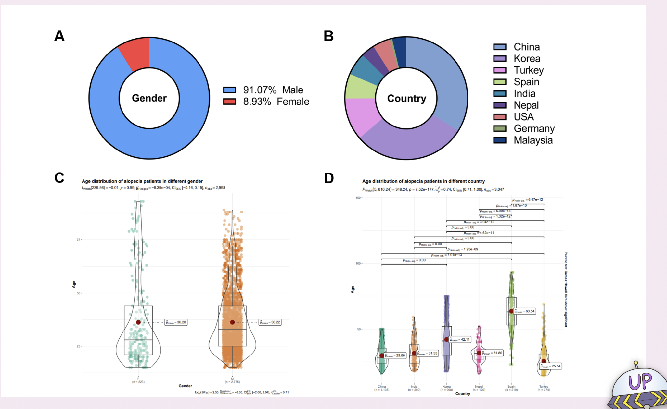
https://2018.igem.org/Team:CPU_CHINA/Model#LGD
https://2018.igem.org/Team:XJTLU-CHINA/Modelling1 not very useful
https://2022.igem.wiki/ustc/model
https://2022.igem.wiki/dku/model.html

